

BookBuster Library
  - Normalization Report
 | RElational databases, Group 3 |  | Prepared by BRad Kajganich, Zemmat Hagos, Najaf Ali



Overview
This report is a review of the data normalization process and database structure determined by a set of sample data (attached). In this report, we break down the normalization process and what was done to reduce redundancy and organize dependencies logically.

Sample data
Below is some sample data written to illustrate the necessary changes that were made to our database to achieve each level of normalization: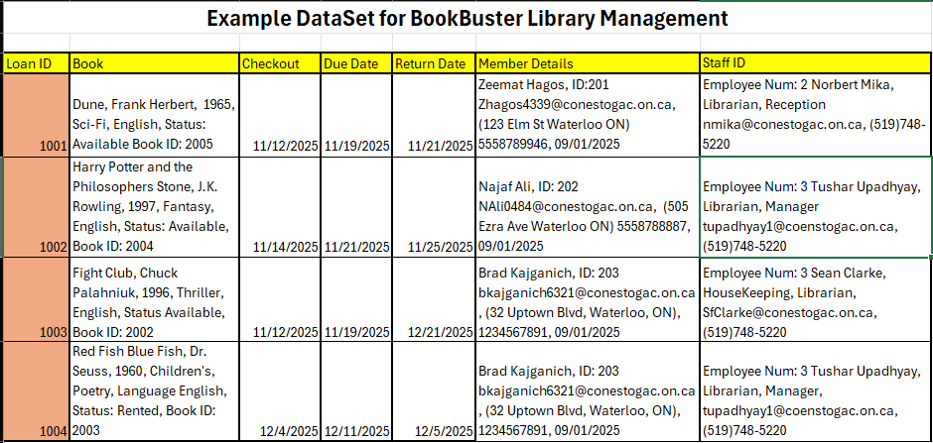
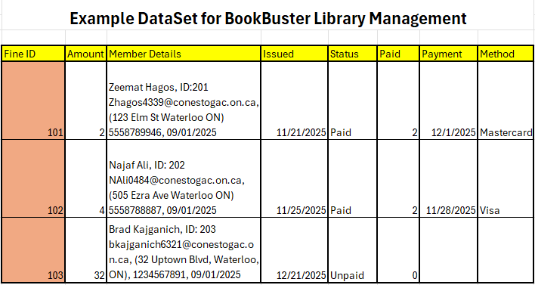

First form normalization

ATomicity
The first thing we did, in the interest of readability, was to separate each of the Book, Member Details and Staff ID columns into their own tables. This made things easier to examine moving forward. Even after separation, we could see that in the case of our Book and Staff Tables, the Genre and Role columns did not have full atomicity. To break this down, we reconfigured a bridge table to allow for this. Below is a breakdown of those adjustments:

BOOKS:

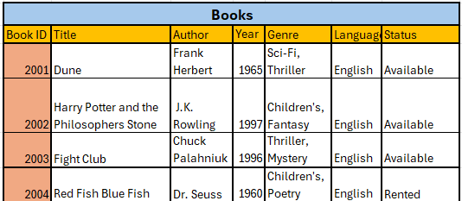
WOULD BECOME:
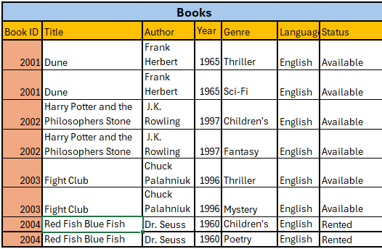

STAFF:
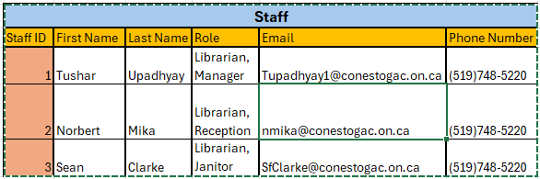
WOULD BECOME:
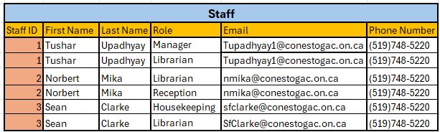

MEMBER DETAILS WOULD BECOME:
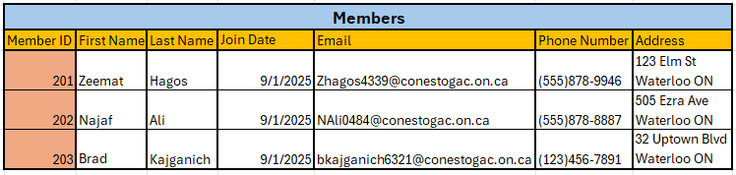
(No further changes to reach 1nf)

After making these changes and implementing them in the existing sample dataset, we can see that all values are atomic and no rows are repeated. Moving forward, we investigate Second normal form and how we can reduce redundant data through bridge tables and further normalize our sample data.

Second form normalization

Partial dependency elimination
The second step in our process was to eliminate partial dependencies. Regarding our previous adjustments, that involved making bridge tables to accommodate the Roles and Genres previously outlined. Those bridges were defined as follows:
BOOKS AND STAFF WOULD BECOME:
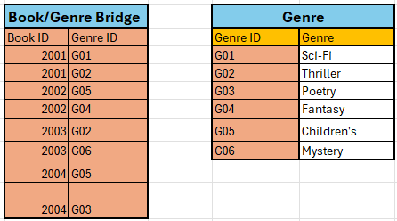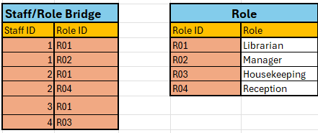

Third form normalization

Transitive dependency elimination
Finally, to further remove partial dependencies, we have made the following adjustments:
- FineAmount is $1.00 per day past due date, equivalent to:
Greatest((LoanID.ReturnDate – LoanID.CheckOutDate), 0).
- Also, our Fine Tables FineID.DateIssued property can be defined as:
LoanID.ReturnDate.
- Furthermore, our FineID.StatusOfFine can be determined by the connected table “Payment” such that:
FineID.StatusOfFine = “Unpaid” IF
(Max (LoanID.ReturnDate – LoanID.CheckOutDate, 0) – FineID.PaymentID.AmountPaid) >= 0
Else FineID.StatusOfFine = “Unpaid”),
- Considering all the above, the best way to normalize our data was to create a Fine Table as a bridge between our Payments table and our Loans table (in the event that a Loan does not incur a fine), but with a much more limited structure and dedicated dependencies. Below if an updated ER diagram of our database structure in full third normal form.

